
Hanslope Village Hall
A Charitable Incorporated Organisation

Registered Charity No: 1165557

Safeguarding Policy

Statement of Intent

  - Hanslope Village Hall CIO Village Hall Trustees, staff, volunteers and hirers have a duty to safeguard vulnerable users of the hall and its premises and those who may come into contact with vulnerable users.
  - They should respond to any concerns they may have regarding the physical, sexual, emotional or psychological safety of a vulnerable person or concerns relating to discriminatory or financial violation or exploitation of a vulnerable person.
  - This policy is in place to protect all vulnerable persons regardless of gender, ethnicity, disability, sexuality, religion or faith.
  - This policy applies to all users of the village hall and its car parks.

Principles
  - The welfare of the child or vulnerable adult is paramount and is the responsibility of everyone. All children and vulnerable adults, without exception, have the right to protection from abuse, whether physical, verbal, sexual, bullying, exclusion or neglect. Bullying, shouting, physical violence, sexism and racism towards children will not be permitted or tolerated.
  - The responsibility for ensuring the safety of children or vulnerable adults while at the hall rest with the individual or organisation hiring the hall.

Policy Statement
  - No member of the trustees, their staff or hall volunteers will have unsupervised access to children or vulnerable adults.
  - All suspicions or allegations of abuse against a child will be taken seriously and dealt with speedily and appropriately.
  - All trustees need to be aware of this policy, child protection, and vulnerable adult issues. See Appendices.

  - There will be a nominated and named Vulnerable Users representative to who any suspicions or concerns should be reported. This person is: Gillian Glandville. (safeguarding@hanslopevillagehall.co.uk )
  - The trustees will endeavour to keep the premises safe for use by children and vulnerable adults and they recognise that a higher standard of safety is required where use is made by small children, those who cannot read safety notices and physically disabled adults.
  - Any organisations or individuals hiring the hall for the purposes of holding activities involving children or vulnerable adults are confirming by signing the terms and conditions of Hire that they have an appropriate safeguarding policy in place.
  - The Trust will ensure that hirers are made aware of their obligations under the Licensing Act 2003 to ensure that alcohol is not sold to those under the age of 18. The Trust will ensure that hirers are aware that no children may be admitted to films when they are below the age classification for the film or show. No gambling or entertainment of an adult or sexual nature shall be permitted on the premises.
  - This policy and procedures will be reviewed annually and updated as appropriate in the interim periods.

Useful Procedures
  - All trustees, staff and volunteers will be given information about child protection awareness as appropriate (see appendices).
  - An annual review will take place at the first Board of Trustees meeting of each year to allow for any required up-date of policies and or procedures. New trustees must be given an induction to this policy and understand their responsibilities.
  - A copy of the policy will be displayed for the attention of all in the village hall and made available on request to hirers.
  - Organisations hiring the hall for activities for children will be asked to confirm that they have suitable Child Protection policies in place before the first booking commences. Individuals hiring the hall for activities for children will be made aware of this policy. Organisations hiring the hall for activities specifically involving vulnerable adults will be asked to confirm that they have a suitable Vulnerable Adults Protection policy before the first booking

commences. All organisations hiring the hall will be made aware of this policy.
  - The committee will require hirers to report any damage, breakages or safety issues needing attention to the hall manager, who will inform the appropriate people. These will be dealt with as soon as practicable, in the light of the circumstances, with provision to prevent access by children and vulnerable adults pending repair where appropriate.
  - A hiring agreement which includes appropriate Safeguarding clauses will be entered into for all hirings. The Trust will ensure that these Safeguarding provisions are observed when holding any licensable activities. The trustees will give written instructions to those selling alcohol concerning the licensing offences which must be avoided.
  - Contractors engaged to carry out work at the premises must not be allowed unsupervised access to children or vulnerable adults. All work should be undertaken when the hall is not in use, but appropriate supervision will be arranged if it is necessary to carry out work when the hall has been booked.
  - If the premises might be used by more than one hirer, the attention of hirers will be drawn to the need to ensure that children and vulnerable adults are supervised when using toilets.
  - The supervision of all groups remains the responsibility of the people who hire the hall and sign the terms and conditions of booking.
Signed: 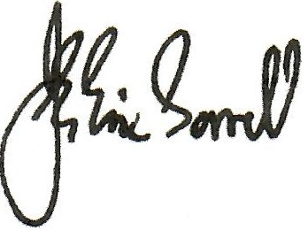 John Eric Sorrell

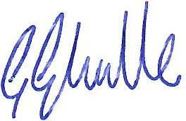
Chairman of the Board of Trustees

Signed:

Gillian Glanville

Child Protection Vulnerable Users Representative and Safeguarding Officer

